Maumee River PaddleFest / EcoTour

WESTERN LAKE ERIE
WATERKEEPER ASSOCIATION

MEMBER
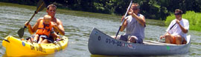

Sunday, June 7th 2009 9:30 am – 1:00 pm

Please join us for an enjoyable, naturalist-led float trip down the Maumee River & the

The Western Lake Erie Waterkeeper Association

In Partnership with River Lures of Grand Rapids, OH & Great Lakes Freshwater Future
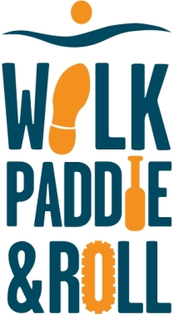
Join Freshwater Future in our Great Lakes Walk, Paddle, and Roll to support grassroots efforts to keep our lakes, rivers, wetlands and drinking water clean and healthy.
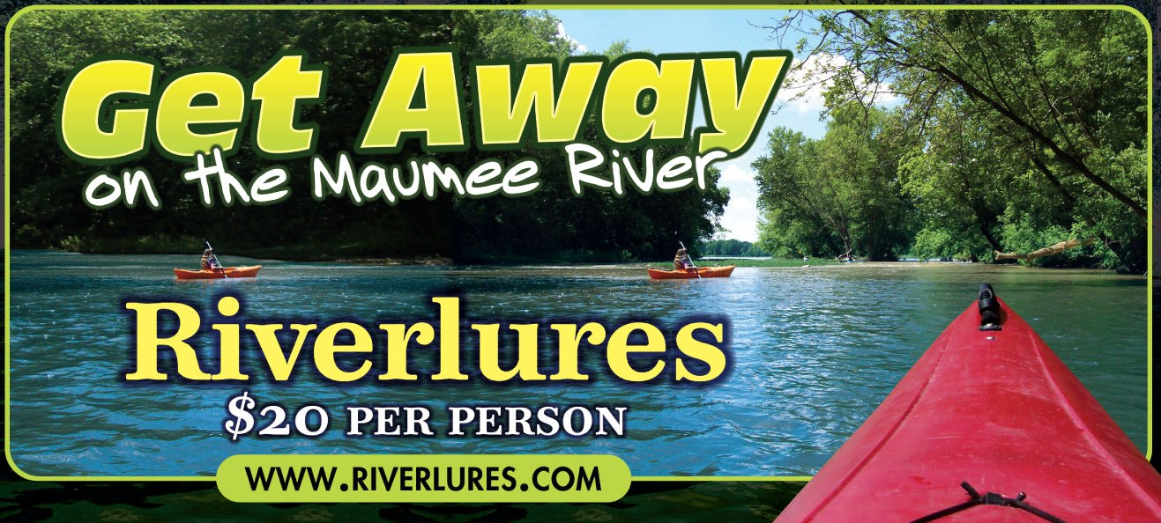

Bring your kayak or canoe or get a discount rental from River Lures
We’ll set a shuttle up at Farnsworth Metropark in Waterville, put our boats into the Maumee River at Grand Rapids, paddle/float leisurely along some of the most beautiful scenery in NW Ohio, then enjoy hamburgers, hot dogs and picnic fare afterwards.
Participation fee: $10.00 per person (with your own boat) Collect $50.00 or more in pledges & registration is free!!!
Rental fee: $15 for canoe/kayak and $10 for each person includes registration.
For more information go to www.westernlakeerie.org

REGISTRATION FORM: (All participants will be required to sign a liability waiver) – Due June 1
Maumee River Paddlequest – Sunday June 7 9:30-1:00 Start at River Lures Grand Rapids – Continental Breakfast – Paddle to Farnsworth
Cost: $10 (includes continental breakfast and lunch) with your own canoe/kayak Cost $15 rent canoe/kayak

Name: __________________________________________________ No. People $10 each ___________ Canoe$15____ Kayak $15______

Mailing Address __________________________________________City/State/Zip Code______________________________________

Telephone _________________________________________Email __________________________________________________

Amt. for payment: _______________Check(Make payable to Western Lake Erie Association) Credit card Visa _____ Master Card _____
Name as it appears on Credit Card – Please Print: ________________________________________________________________

Credit Card No. _____________________________________Expiration Date (Month/Year) ________________________
(Credit cards will be processed by the Click and Pledge for WLEA)

Mail to: Maumee Paddle Quest 6565 Bayshore Rd. Oregon, Ohio 43618 Questions: 419-691-3788 or:sandylakeerie@aol.com Fax: 419-691-2288

