

BAY SHORE POWER PLANT
COOLING WATER INTAKE STRUCTURE
INFORMATION
AND
I&E SAMPLING DATA

Kinectrics Report: 112026-005-RA-0002-R00

January, 2008

Darlene Ager, Ph.D., David Marttila, Eng, Paul Patrick, Ph.D.
Environmental and Aquatic Management Services

PRIVATE INFORMATION
Contents of this report shall not be disclosed without the consent of the Customer.

Kinectrics has prepared this report in accordance with and subject to the contract Terms and Conditions between Kinectrics and FirstEnergy, dated October 7, 2004

© Kinectrics North America Inc., 2008

Kinectrics North America Inc., 800 Kipling Avenue
Toronto, Ontario, Canada M8Z 6C4

BAY SHORE POWER PLANT
COOLING WATER INTAKE STRUCTURE

Kinectrics Report: 112026-005-RA-0002-R00

January, 2008

Darlene Ager, Ph.D., David Marttila, Eng. Paul Patrick, Ph.D.
Environmental and Aquatic Management Services

EXECUTIVE SUMMARY

Section 316(b) of the Clean Water Act (CWA) requires that cooling water intake structures reflect the best technology available for minimizing adverse environmental impact to aquatic organisms that are impinged (being pinned against screens or outer part of a cooling water intake structure) or entrained (being drawn into and through cooling water systems). Phase II of the 316(b) rule for existing electric generating plants was designed to reduce impingement mortality by 80-95% and, if applicable, entrainment by 60-90%.

In January 2007, the Second U.S. Circuit Court of Appeals remanded several provisions of the Phase II rule on various grounds. The provisions remanded included:

- EPA’s determination of the Best Technology Available under Section 316(b);
- The rule’s performance standard ranges;
- The cost-cost and cost-benefit compliance alternatives;
- The Technology Installation and Operation Plan provision;
- The restoration provisions; and
- The “independent supplier” provision.

With so many provisions of the Phase II rule affected by the decision, the USEPA suspended the Phase II rule in July 2007.

This report provides of a summary of information pertaining to Bay Shore Power Plant’s Cooling Water Intake Structure (CWIS):

- Source Water Physical Data [40 CFR 122.21(r)(2)];
- Cooling Water Intake Structure Data [40 CFR 122.21(r)(3)];
- Cooling Water System Data [40 CFR 122.21(r)(5)]
- Rates of Impingement and Entrainment of Fish at Bay Shore Power Plant’s CWIS.

TABLE OF CONTENTS

Page

EXECUTIVE SUMMARY ii
1.0 INTRODUCTION 1
1.1 Site Location 1
1.2 Facility Description 2
2.0 SOURCE WATER PHYSICAL DATA 3
2.1 Maumee River 3
2.2 Estuary Characteristics 3
3.0 COOLING WATER INTAKE STRUCTURE DATA 7
4.0 COOLING WATER SYSTEM DATA 10
5.0 ENTRAINMENT 11
5.1 Egg Entrainment 11
5.1.1 Historical Levels of Fish Egg Entrainment 11
5.2 Larval Fish Entrainment 14
5.2.1 Historical Levels of Larval Fish Entrainment 17
5.3 Juvenile Fish Entrainment 20
6.0 IMPINGEMENT 23
6.1 Historical Levels of Fish Impingement 23
6.2 Species List 29

7.0 REFERENCES 32

TABLES
Page

Table 1.1 Capacity of Bay Shore Generating Units 2

Table 4.1 Monthly Cooling Water Volumes (April 2005 – December 2006) 10

Table 5.1 Annual Estimate of Fish Eggs Entrained at Bay Shore Power Plant 12

Table 5.2 Comparision of Fish Egg Entrainment at Bay Shore 12

Table 5.3 Annual Estimate of Fish Larvae Entrained at Bay Shore Power Plant 15

Table 5.4 Annual Estimate of Fish Larvae (Excluding Long Dead Larvae) Entrained at Bay Shore Power Plant 16

Table 5.5 Comparison of Larval Entrainment at Bay Shore 18

Table 5.6 Annual Number of Estimated Entrainable Juvenile Fish Entrained at Bay Shore Power Plant 21

Table 5.7 Annual Number of Estimated Entrainable Juvenile Fish (Excluding Long Dead Juveniles) Entrained at Bay Shore Power Plant 22

Table 6.1 Annual Number of Estimated Fish Impinged at Bay Shore Power Plant (May 2005 – December 2006) 25

Table 6.2 Annual Weight (kg) of Estimated Fish Impinged at Bay Shore Power Plant (May 2005 – December 2006) 26

Table 6.3 List of Specimens Entrained and Impinged at Bay Shore Power Plant, (May 2005 – December 2006) 31

FIGURES
Page

Figure 1.1 General Area Near the Bay Shore Power Plant (Reutter et al., 1978) 1

Figure 1.2 Intake at the Bay Shore Power Plant 2

Figure 2.1 Map of the Maumee River Watershed 4

Figure 2.2 Streamflow Measured in Water Year 2005 and the Distribution of Streamflow Measurements made During Water Years 1996-2004, Maumee River at Waterville, Ohio. 5

Figure 2.3 Streamflow During Water Year 2005 Compared with Median Streamflow for Period 1971-2000, Maumee River at Waterville, Ohio. (Mangus and Frum, 2005) 5

Figure 3.1 Overview and Lateral View of Traveling Screens at the Bay Shore Power Plant (Reutter et al., 1978) 8

Figure 3.2 Flow Distribution/Water Balance Diagram for Bay Shore Plant 9

Figure 5.1 Bay Shore Estimated Fish Egg Entrainment: 2005-2006 versus 976-1977 13

Figure 5.2 Bay Shore Estimated Larval Fish Entrainment: 2005-2006 versus 1976-1977 19

Figure 5.3 Comparison of Most Prominent Entrained Larval Fish at Bay Shore Power Plant 20

Figure 6.1 Comparison of Estimated Impingement Levels at Bay Shore 24

Figure 6.2 Comparison of Estimated Fish Impingement Levels at Bay Shore Power Plant 27

Figure 6.3 Comparison of Most Prominent Impinged Species at Bay Shore Power Plant 28

GLOSSARY OF TERMS

MGD million gallons per day

YOY young-of-the-year

YSL yolk-sac larvae

PYSL post-yolk-sac larvae

JUV juvenile

TL total length

BAY SHORE POWER PLANT
COOLING WATER INTAKE STRUCTURE

1.0 INTRODUCTION

1.1 Site Location

The Bay Shore Power Plant is located on the southern shore of Maumee Bay, near the mouth of the Maumee River, at the western end of Lake Erie, near Oregon, Ohio. Cooling water for Bay Shore is obtained from the Maumee River/Maumee Bay via an open intake channel and after traversing the condensers, is discharged to Maumee Bay (Figure 1.1).

Figure 1.1 General Area Near the Bay Shore Power Plant (Reutter et al., 1978)

1.2 Facility Description

Bay Shore is a 4-unit, coal-fired facility with a total capacity of 631 MW. The operating capacity for Bay Shore is summarized in Table 1.1.

Table 1.1 Capacity of Bay Shore Generating Units

Unit | Generating Capacity  (MWe)
1 | 136
2 | 138
3 | 142
4 | 215
Total | 631

A photograph of the Bay Shore intake is presented in Figure 1.2. Bay Shore has a surface cooling water intake structure which is described in Section 3.0.

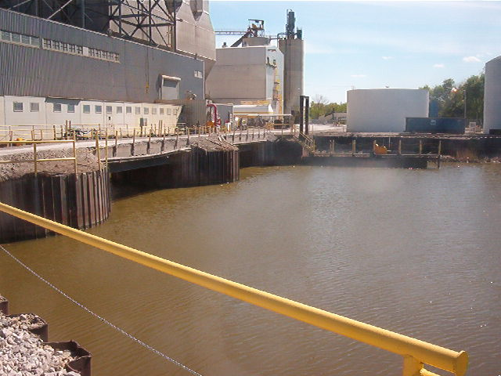

Figure 1.2 Intake at the Bay Shore Power Plant

2.0 SOURCE WATER PHYSICAL DATA

2.1 Maumee River

Bay Shore draws water from the Maumee River/Maumee Bay via an open intake channel which is approximately 3,700 feet in length. The Maumee River is formed in Fort Wayne, Indiana by the merging of the St. Joseph River and St. Marys River. The St. Joseph River forms in Hillsdale County, Michigan and flows southwest into Indiana. The St. Marys River starts in Shelby County, Ohio and flows northwest into Indiana. The Maumee River then flows from Fort Wayne to Toledo, where it empties into Lake Erie. (Smith and Cooper, 1976).

The drainage basin has an area of 6,586 square miles; 1,260 square miles in Indiana, 470 square miles in Michigan and 4,856 square miles in Ohio (Figure 2.1). The diameter of the drainage basin is approximately 100 miles. The average gradient of the Maumee River is 1.3 ft/mile. The St. Marys River averages 2.8 ft/mile and the St. Joseph River averages 1.6 ft/mile. (Smith and Cooper, 1976).

The Maumee River empties into Maumee Bay, at the southwestern end of Lake Erie. The Maumee River has a great range in flows from a low of 400 c.f.s to a high of 10,000, with a median discharge of 5,000 (Figure 2.2). Monthly and yearly mean streamflow for water year 2005 are presented in Figure 2.3. The annual mean discharge for water year 2005 was estimated to be 6,558 cubic feet per second (USGS 04193500 – Maumee River at Waterville OH).

The Maumee is not a large river, but is the largest tributary to Lake Erie. The Maumee River amounts to only 3% of the flow into Lake Erie. Low relief, gentle gradient and fine-grained sediments account for the river’s low velocity, muddiness and sediment clogged beds. (Smith and Cooper, 1976).

2.2 Estuary Characteristics

A detailed summary of estuary characteristics has been presented by Smith and Cooper (1976). Relevant information from this report is presented below.

The lower 15 miles of the Maumee River can be considered a freshwater estuary. The formation of this estuary in Lake Erie was caused by a series of geologic events related to Pleistocene glaciation. The flow of the Maumee River was reversed from its south-westerly direction when the glacial lakes drained from the Lake Erie Basin as the ice sheet melted, exposing the outlet to the Niagara River. The lowering of the base level accelerated river velocity and the Maumee valley was cut deeply into lacustrine deposits, glacial tills and bedrock. Removal of the weight of glacial ice allowed the outlet to rebound, raising the water level in the lake. This increase in water level drowned the river mouth. Due to this configuration, the mouth of the Maumee River has been compared to a marine estuary. Most of the south shore tributaries to the lake have estuarine-like lower reaches where the lake water masses affect water level and quality several miles upstream from the traditional mouths.

The estuary of the Maumee River begins just above the Maumee-Perrysburg Bridge where the bedrock riffles end. Lake effects (flow reversal, sudden change in stage and volume, stagnation, and extreme instability of flow) are felt from the lake up to the riffles.

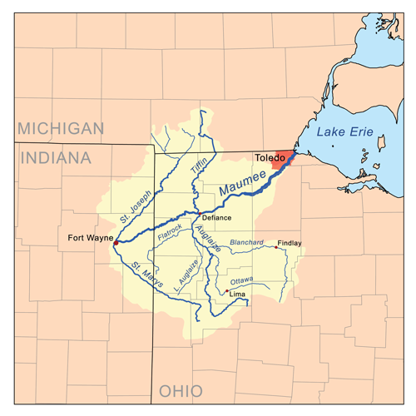

Figure 2.1 Map of the Maumee River Watershed

Figure 2.2 Streamflow Measured in Water Year 2005 and the Distribution of Streamflow Measurements made During Water Years 1996-2004, Maumee River at Waterville, Ohio. (Mangus and Frum, 2005)

Figure 2.3 Streamflow (cubic feet per second) During Water Year 2005 Compared with Median Streamflow for Period 1971-2000, Maumee River at Waterville, Ohio. (Mangus and Frum, 2005)

At low flow, the Maumee River has little to do with the quantity or exchange rate of water in the estuary. The Maumee estuary is controlled by the level of western Lake Erie and by winds. When the winds blow steadily out of the southwest, the lake falls at Toledo and the water stored in the estuary spills out; when the winds blow out of the north-east, the lake rises at Toledo and the resulting estuarine backflow may drown the lower end of the riffle above the Perrysburg Bridge. In effect, the estuary is a huge, flat lagoon which receives the waters of the free-flowing Maumee and great volumes of Lake Erie water that enter it when backflow is induced by rising lake levels. Obviously, this great “slosh basin” cannot be treated as a free-flowing stream. In fact, the flow which enters the upper end of the estuary is seldom an important hydraulic factor.

The currents in the estuary are basically reversing in nature. The primary generating forces are short-period water-level oscillations (wind tides, surges, and seiches) in Lake Erie, and discharge from the Maumee River. The highest current speeds occur during the formation of a wind tide due to strong southwest winds (causing a rapid fall in water level) along with a significant discharge from the Maumee River.

Large water-level rises in the estuary are not as frequent as at the eastern end of the lake because southwest winds predominate over northeast winds. The frequency of occurrence of various water level rises above mean lake level due to any cause indicates that water level rises increase rapidly to about 4.0 feet (1.2-1.4 meters). A wind tide in excess of 5.0 feet (1.4-1.5 meters) would be an exceptional event.

Currents produced by these water level changes as well as by the flow from the estuary are similar to tidal currents, i.e., the direction of the flow periodically reverses. The current maintains its reversing characteristics when the river discharge is below 7,000 c.f.s. and the effect that the river discharge has on current speed is difficult to determine. Only during periods of rapid rise in lake level does the current change direction from its downstream course (river discharge above 7,000 c.f.s.).

At discharge rates of 20,000 c.f.s or greater, periods of rapid rise in lake level have little effect on the dominant downstream current direction. The latter rate of flow is very infrequent and normally of short duration (Figure 2.2).

Within the shipping channel, outgoing currents range from 0 to 1.5 ft/sec. When the river discharge is moderate (7,000 c.f.s.), the mean velocity at the mouth of the Maumee River ranges from 0.3-0.5 ft/sec. At low discharge (under 350 c.f.s.) the current is aimless. A downstream current at the mouth is persistent about 75 percent of the time. In general, currents in the bay flow outward along the navigation channel about 60 percent of the time.

3.0 COOLING WATER INTAKE STRUCTURE DATA

The Bay Shore Power Plant is located on the southern shore of Maumee Bay at approximately 41º 41’ 00” N latitude and 83º 26’ 00” W longitude, near the mouth of the Maumee River, at the western end of Lake Erie, near Oregon, Ohio. Cooling water for Bay Shore is obtained from the Maumee River/Maumee Bay via an open intake channel and after traversing the condensers, is discharged to the Maumee Bay (Figure 1.1).

Bay Shore draws water from the Maumee River/Maumee Bay via an open intake channel which is approximately 3,700 feet in length. During dry periods of the year (summer), the required plant intake flow may exceed river flow although a grassy island splits the river at this location. In this period, an additional source of intake water is derived from Maumee Bay and Lake Erie.

Bay Shore has nine vertical traveling screens (3/8 in openings), each of which has a bar rack (Figure 3.1). Screen #4 runs only for 15 minutes per day and screen #7 runs for 30 minutes per 12-hr shift. Screen #9 has a small gap between the bottom of the screen and the support structure which does allow for debris to enter the plant. Water is drawn at a depth of approximately 12 feet. The design intake capacity is 810 MGD. Collected fish and debris are sprayed and washed in a sluiceway which discharges into Maumee Bay.

The design-through-screen velocity varies but has been estimated at 2.58 ft/s but approach velocity can be lower.

Heated discharge water is recirculated into the intake area in winter when the intake temperature drops below 35ºF. A gate between the intake and discharge canals is opened and remains open until spring (December to late March) when water temperatures rise. Approximately 10% of the total plant cooling water is recirculated at these times. Most of the recirculated water enters the Unit 1 condenser where the Maximum ΔT attributable to recirculated water is 2-3ºF (Reutter et al., 1978).

The Bay Shore Station uses water from the Maumee River/Maumee Bay predominantly for cooling of the condensers. It uses city water for several plant processes including sanitary and boiler make-up water. The maximum pumping capacity for the intake structure is 810 MGD. The annual average used is 638.3 MGD. Refer to Figure 3.2 for a more comprehensive Flow Distribution/Water Balance Diagram for Bay Shore Plant.

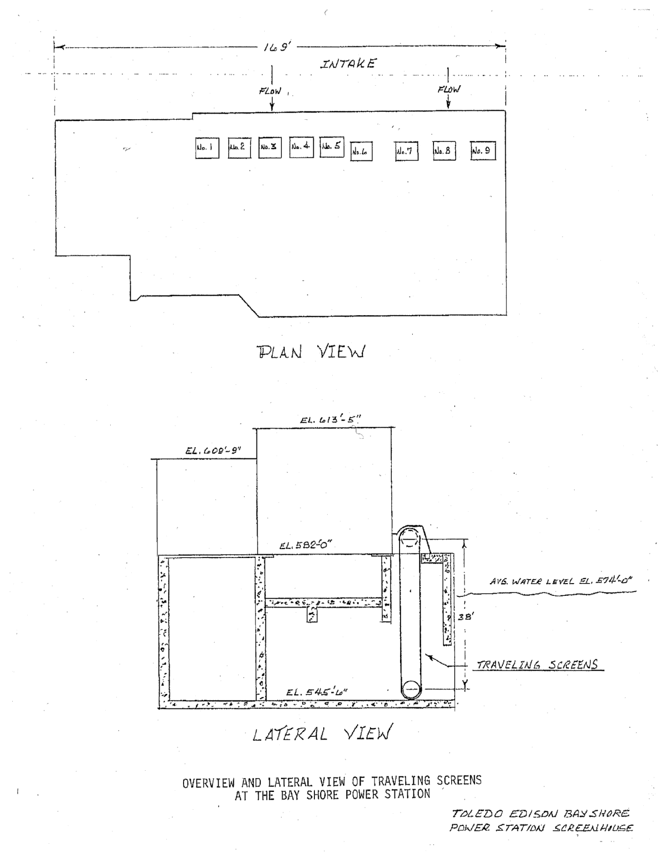

Figure 3.1 Overview and Lateral View of Traveling Screens at the Bay Shore Power Plant (Reutter et al., 1978)

Figure 3.2 Flow Distribution/Water Balance Diagram for Bay Shore Plant

4.0 COOLING WATER SYSTEM DATA

The maximum pumping capacity for Bay Shore is 810 MGD. Daily cooling water flow volumes for the time period April 2005 to December 2006 are summarized in Appendix 1. Over the duration of this study, the monthly cooling water volume ranged between 20,727 and 23,123 million gallons with a mean monthly volume of 22,546 + 704 million gallons (Table 4.1).

Table 4.1

Monthly Cooling Water Volumes (April 2005 – December 2006)

Month | Million Gallons
Apr-05 | 22,377
May-05 | 20,727
Jun-05 | 22,377
Jul-05 | 22,386
Aug-05 | 22,178
Sep-05 | 22,377
Oct-05 | 23,123
Nov-05 | 22,377
Dec-05 | 23,123
Jan-06 | 23,123
Feb-06 | 20,885
Mar-06 | 23,123
Apr-06 | 22,377
May-06 | 23,123
Jun-06 | 22,377
Jul-06 | 23,123
Aug-06 | 23,123
Oct-06 | 23,123
Nov-06 | 22,377
Dec-06 | 23,123
Average | 22,546
S.D. | 704
Min | 20,727
Max | 23,123

5.0 ENTRAINMENT

Entrainment sampling was conducted at Bay Shore between May 12, 2005 and May 12, 2006. Detailed summaries of the entrainment data and associated analyses are presented in Kinectrics Report No. 112026-005-RA-0001-R00.

5.1 Egg Entrainment

A total of 9,967 fish eggs were collected during the 2005-2006 entrainment sampling program. The majority of fish eggs (99.7%) were categorized as dead/long dead. On an annual basis, it is estimated that a total of 208,565,490 fish eggs were entrained at Bay Shore (Table 5.1). The majority of fish eggs entrained were freshwater drum (97.5%).

Freshwater drum (also known as sheephead) are commonly considered an undesirable rough fish (i.e., undesirable as a food or sport fish and often viewed as a competitor of more desirable fishes).

5.1.1 Historical Levels of Fish Egg Entrainment

A comparison of fish egg entrainment data for 2005-2006 versus 1976-1977 is presented in Table 5.2 and Figure 5.1. The annual number of eggs entrained at Bay Shore between September 1976 and September 1977 was estimated to be 426 million. This value is approximately twice that estimated for 2005-2006 (208 million fish eggs). For both sampling programs, the most abundant species entrained was freshwater drum (>97%) (Reutter et al., 1978).

Although estimated numbers of fish eggs entrained at this plant are large, they may not be particularly significant. For example, the population of fish eggs in the Maumee River was estimated to be approximately 2.4 billion in 1977 (Reutter et al., 1978). For 1976-1977, 17.3% of the river population was estimated to be entrained at Bay Shore.

River sampling was not conducted during the 2005-2006 sampling program. However, it may be assumed that the density of fish eggs in the intake canal of Bay Shore is comparable to the river density. However, variability from year to year can be expected. Based on 2005 discharge information for the Maumee River (USGS 04193500 – Maumee river at Waterville OH), the river population of larval fish is estimated to be approximately 1.8 billion in 2005. For 2005-2006, 11.4% of the river population was estimated to be entrained at Bay Shore.

Table 5.1

Annual Estimate of Fish Eggs Entrained at Bay Shore Power Plant

(May 2005 – May 2006)

Individual estimates may not add to totals due to rounding.
No fish eggs were entrained in July, August, September 2005 or March and April 2006.

Table 5.2

Comparision of Fish Egg Entrainment at Bay Shore

(2005-2006 versus 1976-1977)*

- 1976-1977 data obtained from Reutter et al., 1978.
- Note: typical survival rates to age 1 of freshwater drum eggs is 1in 25,000.

Figure 5.1

Bay Shore Estimated Fish Egg Entrainment: 2005-2006 versus 1976-1977

208 million (11% of River)
2.4 billion
(estimated)
1.8 billion (estimated)
426 million (17% of River)

5.2 Larval Fish Entrainment

A total of 118,287 larval fish were collected during the 2005-2006 entrainment sampling program. On an annual basis, it is estimated that a total of 2,247,249,020 larval fish were entrained at Bay Shore (Table 5.3). The most abundant taxa were Freshwater drum (43.5%), Rainbow smelt/Cluepeidae (23.9%) and Morone spp. (6.1%). The “success rate” for eggs and larvae can be expressed as survival to age 1. The majority of eggs and larvae entrained at Bay Shore were freshwater drum. Survival is highly dependent on species, but for freshwater drum, approximately 1 in 25,000 eggs survive to age 1 (0.004%). Approximately 1 in 2,500 larvae survive to age 1 (0.04%). Survival for rainbow smelt eggs is even lower, approximately 1 in 33,000,000 survive to age 1 (0.00003%). Approximately 1 in 303 rainbow smelt larvae survive to age 1 (0.3%)

The initial condition of the larval fish was recorded as part of the entrainment abundance study.
Recently dead larva are considered to represent those larva damaged during sample collection and/or recent natural mortality. The majority of larval fish (79.3%) were categorized as recently dead. Criteria for recently dead include:

- non-motile,
- body transparent or translucent,
- gut defined,
- myomeres well defined,
- fins or fin buds well defined, and
- body tissue or outline well defined.

Long dead larva are considered to represent those larva that were dead prior to being entrained at Bay Shore. Approximately 21% of larval fish were categorized as long dead. Criteria for long dead include:

- non-motile, opaque,
- fins or fin buds not definable,
- myomeres not definable,
- gut absent, and
- body tissue or outline not well defined.

On an annual basis, it is estimated that a total of 1,745,126,022 live and recently dead larval fish were entrained at Bay Shore (Table 5.4). The most abundant taxa were Freshwater drum (53.9%), Rainbow smelt/Cluepeidae (22.1%) and Morone spp. (7.2%).

Freshwater drum (also known as sheephead) are commonly considered an undesirable rough fish (i.e., undesirable as a food or sport fish and often viewed as a competitor of more desirable fishes).

Table 5.3

Annual Estimate of Fish Larvae Entrained at Bay Shore Power Plant

(May 2005 – May 2006)

Individual estimates may not add to totals due to rounding.
Note: typical survival to age 1 of freshwater drum is 1 in 2500, typical survival to age 1 of rainbow smelt is 1 in 303

Table 5.4

Annual Estimate of Fish Larvae (Excluding Long Dead Larvae) Entrained at Bay Shore Power Plant

(May 2005 – May 2006)

5.2.1 Historical Levels of Larval Fish Entrainment

A comparison of larval entrainment data for 2005-2006 versus 1976-1977 is presented in Table 5.5 and Figure 5.2. The annual number of larvae entrained at Bay Shore between September 1976 and September 1977 was estimated to be 284 million. The most abundant species entrained were gizzard shad (78.4%), white bass (11.6%) and freshwater drum (4.7%) (Reutter et al., 1978). A comparison of the most prominent species in the 1976-1977 versus 2005-2006 sampling programs is presented in Figure 5.3.

The number of larval fish estimated to be entrained at Bay Shore between May 2005 and May 2006 is approximately 8 times greater than that estimated for the time period between September 1976 and September 1977. The increase in entrainment appears to be related to an increase in larval fish densities in the Maumee River/Maumee Bay and thus, at the Bay Shore intake (Table 5.5). The average density of larval fish for the 1976-1977 sampling program was estimated to be 86 larvae per 100 m³. For the 2005-2006 sampling program, the density of larval fish was estimated to be 552 larvae per 100 m³. The increase in larval fish densities may be associated with beneficial changes in landuse practices in the Maumee watershed since the 1970s which have led to improvements in water quality and habitat conditions for fish spawning and nursery areas (Roseman et al., 2002).

Although estimated numbers of larvae entrained at this plant are large, they may not be particularly significant. For example, the population of larval fish in the Maumee River was estimated to be approximately 7.3 billion in 1977. For 1976-1977, 3.9% of the river population was estimated to be entrained at Bay Shore. (These estimates are based on river flow rates which may not be appropriate for all species, as several species were shown to be more prevalent when the intake water was of lake or bay origin. This estimate does not account for this phenomenon. Reutter et al., 1978)

River sampling was not conducted during the 2005-2006 sampling program. However, it may be conservatively assumed that the density of larval fish in the intake canal of Bay Shore is comparable to the river density. Based on 2005 discharge information for the Maumee River (USGS 04193500 – Maumee river at Waterville OH), the river population of larval fish is estimated to be approximately 21.7 billion in 2005. For 2005-2006, 10.4% of the river population was estimated to be entrained at Bay Shore. This is a preliminary estimate only and not subjected to statistical analysis. Unfortunately, there is a general lack of data on river populations of different larval fish species for 2005-2006. The above discussion represents a “qualitative” comparison the number of organisms entrained relative to river populations.

Table 5.5

Comparison of Larval Entrainment at Bay Shore

(2005-2006 versus 1976-1977)

Figure 5.2

Bay Shore Estimated Larval Fish Entrainment: 2005-2006 versus 1976-1977

2.2 billion (10% of River)
284 million (4% of River)
7.3 billion
(estimated)
21.7 billion (estimated)

Figure 5.3

Comparison of Most Prominent Entrained Larval Fish at Bay Shore Power Plant

(1976-1977 versus 2005-2006)

5.3 Juvenile Fish Entrainment

A total of 742 entrainable juvenile fish were collected during the 2005-2006 entrainment sampling program. (Juvenile fish capable of passing through a 3/8-in mesh screen were considered to be entrainable.) It is estimated that a total of 13,824,022 juvenile fish were entrained between May 2005 and May 2006 (Table 5.6). The most abundant taxa were Rainbow smelt/Clupeidae (31.6%), Emerald shiner (28.3%) and Round goby (15.7%).

The initial condition of the juvenile fish was recorded as part of the entrainment abundance study. The majority of juvenile fish (91.2%) were categorized as recently dead. Long dead juvenile fish are considered to represent those juveniles that were dead prior to being entrained at Bay Shore. Approximately 7% of entrainable juvenile fish were categorized as long dead. On an annual basis, it is estimated that a total of 12,892,936 live and recently dead juvenile fish were entrained at Bay Shore. The most abundant taxa were Rainbow smelt/Clupeidae (31.2%), Emerald shiner (28.2%) and Round goby (15.8%).

Table 5.6

Annual Number of Estimated Entrainable Juvenile Fish Entrained at Bay Shore Power Plant

(May 2005 – May 2006)

Individual estimates may not add to totals due to rounding.

Table 5.7

Annual Number of Entrainable Juvenile Fish (Excluding Long Dead Juveniles) Entrained at Bay Shore Power Plant

(May 2005 – May 2006)

6.0 IMPINGEMENT

A total of 104 impingement events were carried out between May 12, 2005 and December 11, 2006. Sampling was conducted for a total of 16 months during this period. Four months (May, October, November and December) were sampled in both 2005 and 2006. Additional impingement sampling was conducted from October to December 2006 because it was thought that the impingement estimates for the 2005-2006 sampling period were unusually high. Indeed, impingement levels for October to December 2005 (32,213,647) were approximately 3 times higher than observed in 2006 (10,444,297). A comparison of impingement for 2005 versus 2006 is presented in Figure 6.1.

On an annual basis it is estimated that a total of 46,030,006 fish (270,296 kg) were impinged at Bay Shore between May 2005 and May 2006 (Tables 6.1-6.2). The majority of fish (64%) were categorized as recently dead. Approximately 35% of fish were alive and 0.5% of fish were long dead. The most abundant species were emerald shiner (52.3%), gizzard shad (31.1%) and white perch (10.4%).

6.1 Historical Levels of Fish Impingement

The most recent impingement study conducted at Bay Shore was approximately 30 years ago (Reutter et al., 1978). As part of this earlier study, it was estimated that a total of 19,019,144 fish (170,776 kg) were impinged at Bay Shore between September 15, 1976 and September 15, 1977. The most abundant species were gizzard shad (71.8%), yellow perch (8.9%), alewife (6.3%) and emerald shiner (4.7%). A comparison of fish impingement levels at Bay Shore (1976-1977 versus 2005-2006) is presented in Figure 6.2. The number of fish impinged during the 2005-2006 sampling program (46,030,006) was approximately twice that observed during the 1976-1977 sampling program.

A comparison of the most prominent species in the 1976-1977 versus 2005-2006 sampling programs is presented in Figure 6.3. For both sampling programs, gizzard shad and emerald shiner comprised the two most abundant species. Emerald shiner increase was likely related to large year class strength. While alewife represented the third most abundant species in 1976-1977, alewife represented only 0.001% of impinged fish during the 2005-2006 sampling program.

Figure 6.1

Comparison of Estimated Impingement Levels at Bay Shore

(2005 versus 2006)

Table 6.1 Annual Estimated Number of Fish Impinged at Bay Shore Power Plant (May 2005 – December 2006)
Individual estimates may not add to totals due to rounding.

Table 6.2 Annual Estimated Weight (kg) of Fish Impinged at Bay Shore Power Plant (May 2005 – December 2006)
Individual estimates may not add to totals due to rounding.

Figure 6.2

Comparison of Estimated Fish Impingement Levels at Bay Shore Power Plant

(1976-1977 versus 2005-2006)

Figure 6.3

Comparison of Most Prominent Impinged Species at Bay Shore Power Plant

(1976-1977 versus 2005-2006)

6.2 Species List

Over the duration of this study 54 different species of fish were impinged at Bay Shore Power Plant. For entrainment, only one species of fish eggs, 19 species of larval fish and 12 species of juvenile fish were entrained over the duration of the study at Bay Shore Power Plant . In some instances, it was possible to identify entrained specimens only to the level of genus or family. A summary of specimens entrained and impinged at Bay Shore is presented in Table 6.3.

The Ohio Department of Natural Resources (ODNR) uses six categories: endangered, threatened, species of concern, special interest, extirpated and extinct, to define the status of selected wildlife. Two impinged species have been identified by the ODNR as being a threatened species (channel darter) or endangered species (western banded killifish). Two entrained species have been identified by the Ohio Department of Natural Resources as being a species of concern (burbot, lake whitefish).

Western Banded Killifish – Endangered Species

On August 23, 2005 one western banded killifish was collected at Bay Shore. The western banded killifish (Fundulus diaphanus menona) is slender and pike-like in shape with olive colored sides and numerous vertical bands (Figure 6.4). Adult killifish are usually small reaching between 5-10 cm in length. Historically, the western banded killifish has had a limited Ohio distribution, i.e., northcentral/northwest Ohio and the Portage Lakes. The largest Ohio population of F.d. menona remains in Miller Blue Hole, Sandusky County. Because the range of the western banded killifish has declined in Ohio during the 1900’s, this species was listed as endangered in Ohio in 1974 (Poly et al., 1995).

Channel Darter – Threatened Species

On August 12, 2005 two channel darters were collected at Bay Shore. The channel darter (Percina copelandi) is slender and has 10 to 15 small oblong dark blotches along the side. This species is yellowish-olive in color with scales outlined in brown (Figure 6.6.). Channel darters prefer large beach areas, bars, pools, sluggish riffles with silt-free gravel or rocky bottoms. The channel darter was originally found in both Lake Erie and Ohio River drainages. It inhabited the extensive sand and gravel beaches of Lake Erie and of larger rivers in Ohio, particularly where currents were sluggish. Siltation appears to be the major cause of population decline (Smith et al., 1973). This species is now listed as threatened in Ohio.

Burbot – Species of Concern

On May 16, 2005 four burbot larvae were collected at Bay Shore. The burbot (Lota lota) is a catfish-like to eel-shaped fish. Most burbot are dark olive brown to brown, with dark brown mottling on the sides and yellowish creme on the underside (Figure 6.7). The burbot is native to Ohio, and is primarily a Lake Erie species. Burbot prefer deep open water, but move to nearshore and river-mouth areas to spawn in the winter. This species is currently listed as a species of concern. Population reduction is probably the result of changing water quality and resultant reduced oxygen content the deeper waters of Lake Erie (Smith, 1973).

Lake Whitefish – Species of Concern

On April 9, 2006 one lake whitefish larvae was collected at Bay Shore. The lake whitefish (Coregonus clupeaformis) has a long cylindrical body with olive-green to olive-blue coloring and a silvery overcast (Figure 6.8). Lake whitefish are native to the great lakes, and prefer cooler water temperatures. This species is listed as a species of concern. Reduced population levels in Ohio are the result of changing water quality and unregulated harvest (Smith, 1973).

Table 6.3 List of Specimens Entrained and Impinged at

Bay Shore Power Plant, (May 2005 – December 2006)

7.0 REFERENCES

Covert S.A., Kula S.P., Simonson L.A. (2006). Ohio Aquatic Gap Analysis – An Assessment of the Biodiversity and Conservation Status of Native Aquatic Animal Species. Report 2006-1385.

LMS (2003). Toledo Edison Company Bay Shore Station Thermal Mixing Zone Study. Prepared for FirstEnergy by Lawler, Matusky & Skelly Engineers.

Page L.M., Burr B.M. (1991). A Field Guide to Freshwater Fishes. North America North of Mexico. Houghton Mifflin Company.

Poly W.J., Miltner R.J. (1995). Recent Records of the Endangered Western Banded Killifish, Fundulus diaphanous menona, in the Portage River Basin, Ohio. Ohio J. Sci. 95(4):294-297.

Reutter J.M., Herdendorf C.E., Sturm G.W. (1978). Impingement and Entrainment Studies at the Bay Shore Power Station, Toledo Edison Company 316(b) Program, Task II. Report Prepared for Toledo Edison Company.

Roseman E.F., Taylor W.W., Hayes D.B., Fofrich J., Knight R.L. (2002). Evidence of Walleye spawning in Maumee Bay, Lake Erie. Ohio J. Sci. 3:51-55.

Smith H.G., Burnard R.K., Good E.E., Keener J.M. (1973). Rare and Endangered Vertebrates of Ohio. Ohio J. Science 5:257-271.

Smith M.A. and C.L. Cooper. Investigations of Excessive Fish Movements into Power Plant Structures on the Lower Maumee River, Ohio. Prepared for Toledo Company (November, 1976).

Mangus J.P., Frum S.R. (2005). Water Resources Data Ohio Water Year 2005. Volume 2. St. Lawrence River Basin and Statewide Project Data. Water Data Report OH-05-02. U.S. Department of the Interior. U.S. Geological Survey.

USGS Surface-Water Annual Statisics for Ohio. National Water Information System. http://waterdata.usgs.gov/usa/nwis/uv?site_no=04193500
USGS Surface-Water Annual Statisics for Ohio. National Water Information System.
Certain species do not exhibit a free-swimming larval life stage. Round goby transition within the egg and hatch as juveniles with a full complement of fin rays. Regardless of overall length, round goby have been classified as juvenile fish.
Reutter et al. (1978) observed that larval fish densities in the Maumee river exceed those observed in the intake canal of Bay Shore. Mean larval fish concentrations in the Maumee River from April 9 to September 1, 1997 (520.7 larvae per 100 m³) were approximately 6x greater than that observed in the intake canal of Bay Shore (86.2 per 100 m³).
http://www.dnr.state.oh.us/wildlife/resources/mgtplans/specieslist.htm
Endangered Species: A native species or subspecies threatened with extirpation from the state. The danger may result from one or more causes, such as habitat loss, pollution, predation, interspecific competition or disease.
Threatened Species: A species or subspecies whose survival in Ohio is not in immediate jeopardy, but to which a threat exists. Continued or increased stress will result in its becoming endangered.
Species of Concern: A species or subspecies which might become threatened in Ohio under continued or increased stress. Also, a species or subspecies for which there is some concern but for which information is insufficient to permit an adequate status evaluation.

